Ideation Phase
Define the Problem Statements

Date | 01 october 2026
Team ID:
Project Name | StaffSync
Maximum Marks | 2 Marks

Customer Problem Statement Template:
To define the core operational problems HR personnel, department managers, and employees face while managing workforce records, leave applications, and daily attendance, and use those insights to guide the development of StaffSync.
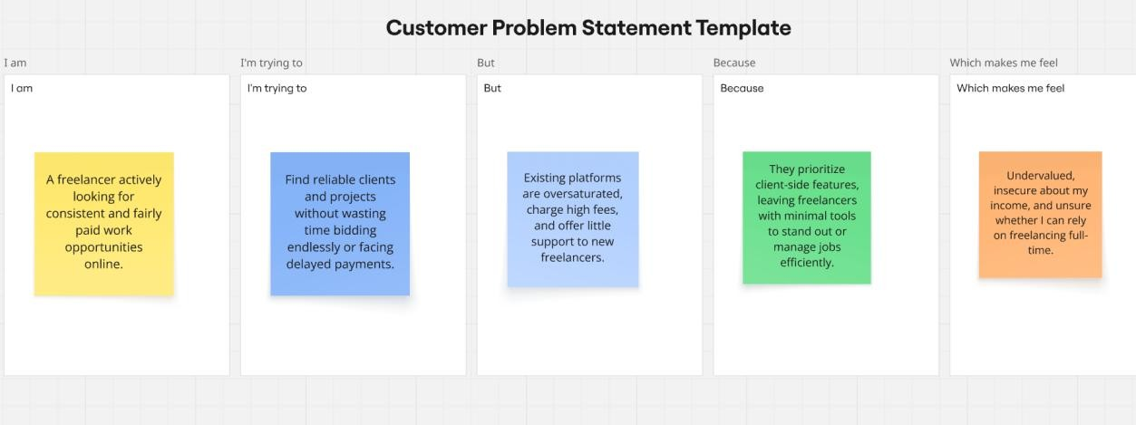
Reference: https://miro.com/templates/customer-problem-statement/

Customer Problem Statement Blocks

Element | Description
I am | An organization stakeholder (HR professional, team manager, or employee) seeking an organized, reliable workplace management system.
I'm trying to | Maintain accurate workforce records, record daily attendance on time, and process leave requests without delays or confusing email trails.
But | Existing processes rely on fragmented spreadsheets, manual physical registers, or disconnected legacy systems that lack role-specific access and  live sync.
Because | Traditional methods lack an integrated, centralized web platform, forcing HR into endless clerical follow-ups and leaving employees uninformed about  request statuses.
Which  makes me feel | Overwhelmed by repetitive administrative bottlenecks, concerned about  attendance and payroll inaccuracies, and frustrated by poor operational transparency.

Problem Statement (PS) Table

Problem Statement  (PS) | I am (Customer) | I’m trying  to | But | Because | Which makes me feel
PS-1 | HR  Personnel / Administrator | Manage company-wide employee records, track attendance records, and review leave requests  efficiently | Scattered spreadsheets and paper trails cause delayed approvals and high manual data entry error rates | There is no unified, real-time platform connecting employees, supervisors, and HR records | Overworked by administrative overhead and stressed about attendance and payroll reconciliation errors.
PS-2 | Department Manager | Oversee team availability, approve leave requests quickly, and track team training  programs | Leave requests get lost in email threads and team capacity is hard to verify at a glance | Supervisory tools are disconnected from employee attendance data and daily shift logs | Hindered in planning project deadlines and frustrated by delayed decision-making.
PS-3 | Corporate Employee | Clock in/out for daily shifts, apply for leaves digitally, and stay updated with company  notices | Applying for leave requires paper forms or awkward manual  follow-ups with uncertain approval times | There is no centralized self-service portal providing instant status updates and clear leave balances | Anxious about request approvals, uncertain about shift records, and disconnected from corporate  updates.

